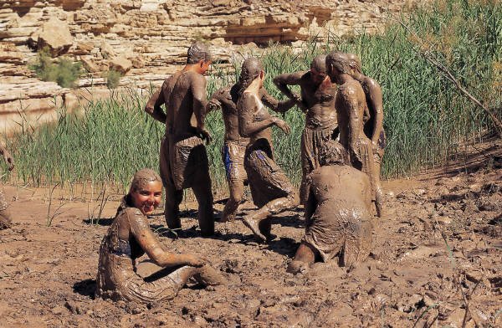

Water Slide and Mud Pit
(Open every day during our summer season)
EVENT DATE: August 12, 2006
EVENT TIME: 10:00 AM
(30 minute session per slide and mud pit)*
Participants have the opportunity to slide to the bottom of our 100 ft. water slide, where a big splash of water awaits them! Our water slide is constructed on a hillside, padded and covered with plastic.

The mud pit is one of our more popular summer attractions. In this area, participants are encouraged to have a good time and GET MUDDY! The mud offers participants the opportunity to engage in all types of fun activities. Games may include “The Mud Obstacle Course”, “Tug of War”, and “King & Queen of the Mud.”
*In order for participants to experience the full benefits of our Water Slide and Mud Pit, we request that you arrive 30 minutes prior to the beginning of each session.
Location: One Beech Lane, Irvine (Meet in the parking lot at 10:00am.)
NOTE: This is a Scout activity but if you are late just join in …you don’t need to tell them you are a Scout for then there is a chance you will have to pay if you say you are in a organized group!
Kids must wear closed-toe shoes and old clothes. Kids younger than 6 must have an adult present with them at all times. ***ANY FEES INCURRED FOR THIS ACTIVITITY IS THE RESPONSIBILITY OF THE PARENTS OR GUARDIANS.

